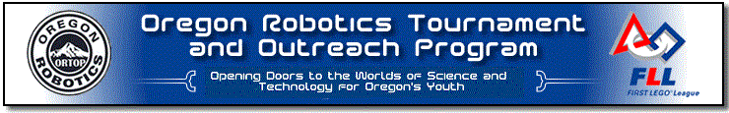
WORKSHOP INFORMATION
WORKSHOPS LOCATION:
Umpqua Community College
June 27, 2015 Technology Center Rooms 119-120
Workshop Time:
One Day Workshop - 8:30 am - 4:30 pm (Breakfast and Lunch Provided)
OTHER USEFUL INFORMATION
- All ORTOP FLL Workshops will utilize the EV3 Robot.
- Participants will work in small teams, 3 - 4 people, to build and program the EV3 robot.
- Workshops with less than 12 registered participants 24 hours prior to class may be rescheduled.
- OPEN ONLY TO ADULTS. No FLL team members are permitted to attend. Please do not bring FLL team members with you.
- FIRST Tech Challenge and FIRST Robotics Competition Teen Mentors are permitted to attend the ORTOP FLL Workshops.
- Workshops are provided at no charge, however, donations to ORTOP to defray our costs are always welcomed. Please consider donating $10 to help with our costs.
- Soda, coffee and water is also provided.
- Many handouts will be provided. Robot and laptop is made available for each workshop team to use during the workshop.
- Visit ORTOP for more details: http://www.ortop.org/fll/index.htm

WORKSHOP DESCRIPTIONS:
Workshop I - Introduction to FIRST LEGO League - 3 hours
Learn the basics of getting started in FIRST LEGO League, hand-on building an EV3 robot and learn some basic programming.
Workshop II - Coaching and Mentoring Techniques - 3 hours
Focus on specific parts of the FLL program - Robot Game, Project and Core Values, best practices for being a coach/mentor, continue to learn programming using robot built in Workshop I
Workshop III - Robotic Techniques - 3 hours
Focus on learning important programming and mechanical design techniques to teach skills to your team. Will use robot built in Workshop II.

OneDay Workshops - 8 hours
One Day Workshops condense the workshop material from Workshops I, II, III into a one day session. These workshop are primarily offered outside of Portland in communities close to FLL Qualifying Tournament sites. The list of cities scheduled changes each year.

Click here to register:
http://www.signupgenius.com/go/10c0c48ada929a6f94-ortop2

